GYROSCOPE
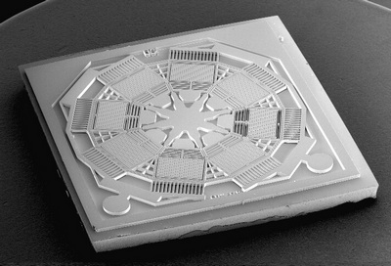
Nowadays every smartphone has a gyro inside. Today it’s usual, but when it appeared it was a real sensation. They can tell where they are geographically, sense proximity, sense linear orientation of the phone. to auto rotate your photos.
Introduction of iPhone 4 saw the addition of another amazing sensor known as "Gyroscope" to mobile phones. Considering their capabilities, we have to be amazed knowing how many hardwares are packed inside these small hand-held devices. They can tell where they are geographically, they can sense proximity, they can sense linear orientation of the phone to auto rotate your photos and now they can also determine your rotation while you are spinning on a swivel chair. Smartphones are just getting smarter.
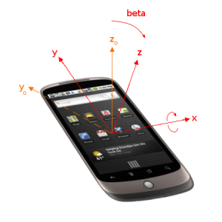
Smartphones usually use gyros and accelerometers for orientation. An accelerometer measures only the linear acceleration of the device and a gyroscope measures the orientation of the device. It can sense motion both vertical and horizontal rotation.
Now the question is why do we need a gyroscope when we already have the accelerometer. An accelerometer measures only the linear acceleration of the device whereas a gyroscope measures the orientation of the device. It can sense motion including vertical and horizontal rotation. There are a lot of practical uses of gyroscope especially in mobile games. Consider a counter-strike like mobile game for an instant. In such games, we are required to move in all directions which also involves rotation around gravity. Again without the support of gyroscope, we need to drag a finger on the touch screen to be able to move in the desired direction and we have to agree that after a while we will began to realize the unfriendliness of the system, in short it will get annoying.
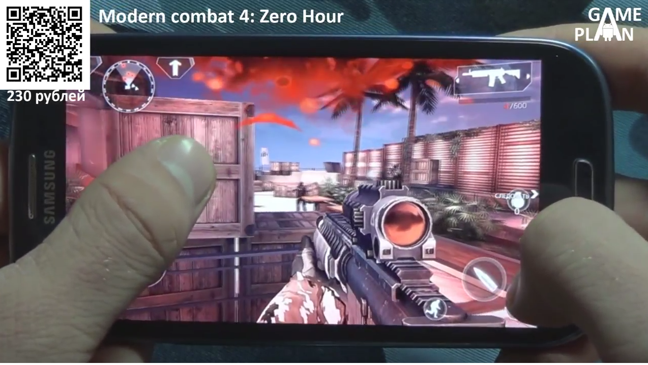
There are a lot of uses of gyroscope especially in mobile games. Think for example about shooters. In these games, we have to move in all directions. Without a gyroscope, we need to drag a finger on the touch screen to move and it not very comfortable.
With the inclusion of a gyroscope user can play these games very smoothly by simply moving the phone or even rotate around the gravity. The gyroscope will detect your motion and system will know what you want to do. With your fingers relieved from aiming and directing, they can do other things like shooting simply by taping the screen. This could also be done using the combination of accelerometer and built-in compass but we would like to have as much smoothness and preciseness as we can get in our life. It is functional and gaming experience will become much more exiting.
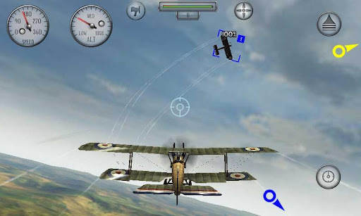
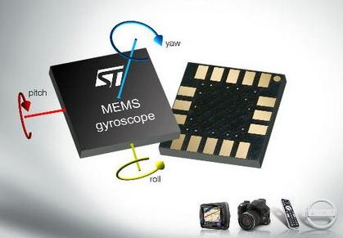
With the help of a gyroscope user can play games by simply moving the phone or even rotate around the gravity. The gyroscope will detect your motion and system will know what you want to do.
In terms of hardware, MEMS(Microelectromechanical systems) based accelerometer and gyroscope are used in mobile phones.
With the help of a gyroscope user can play games by simply moving the phone or even rotate around the gravity. The gyroscope will detect your motion and system will know what you want to do.

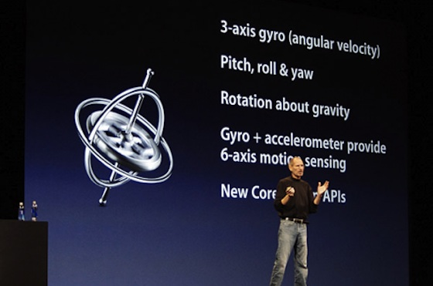
Apple was first to introduce a gyroscope in a mobile phone with the launch of their 4th generation iPhone. Remember when they introduced accelerometer with the first iPhone, it became an instant hit and the trend was set, every smart-phone manufacturer followed them.
Gyroscope changed the way people interact with their mobile phones. With advanced motion sensing achieved with the combination of Gyroscope and Accelerometer we can wait for really cool games and applications.
Gyroscope is all set to change the way people interact with their mobile phones. With advanced motion sensing capabilities achieved with the combination of Gyroscope and Accelerometer

